Behavioral Diagrams :
Use Case Diagrams :
This shows a set of use cases and actors and their relationships. These diagrams illustrate the static use case view of a system and are important in organizing and modeling the behaviors of a system.

For Admin :

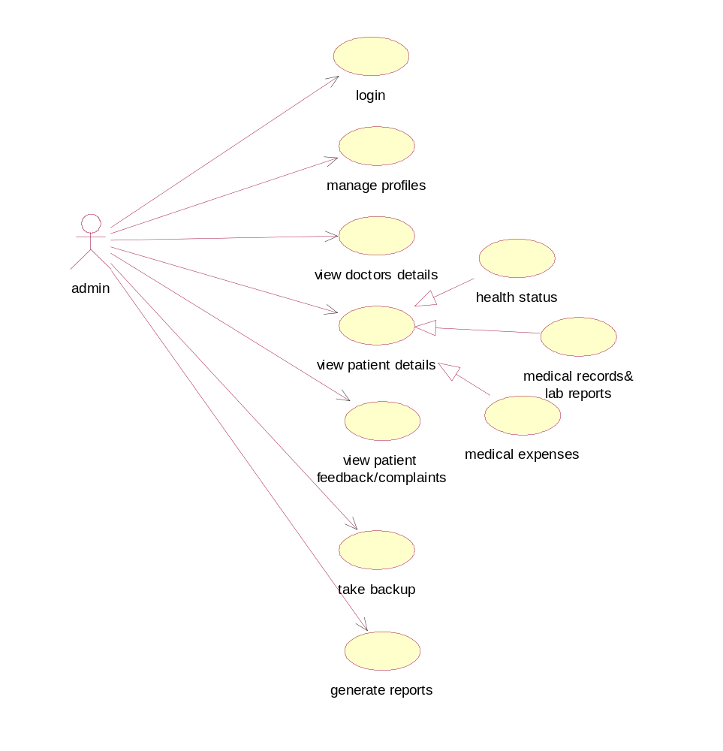

For Doctor :

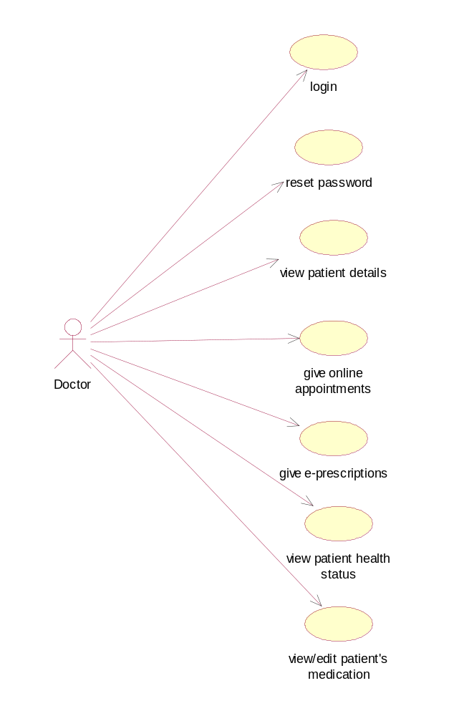

For Patient:
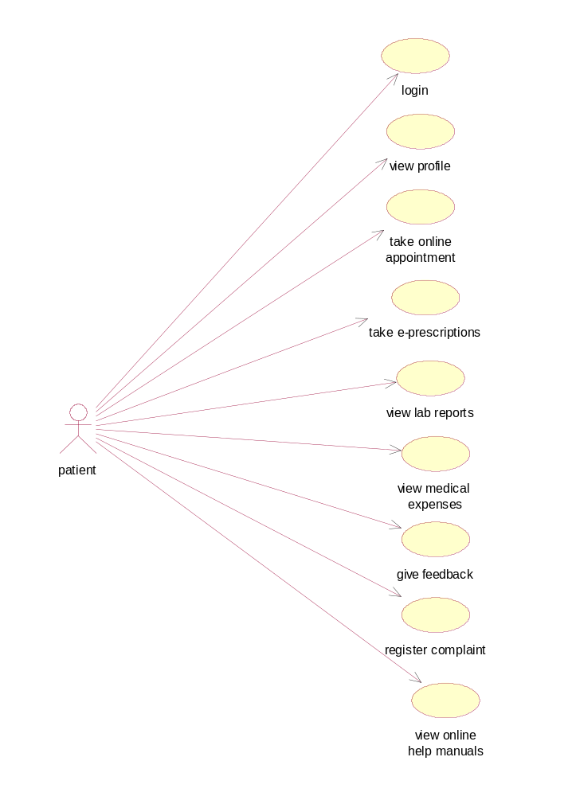

For Kiosk Manager:
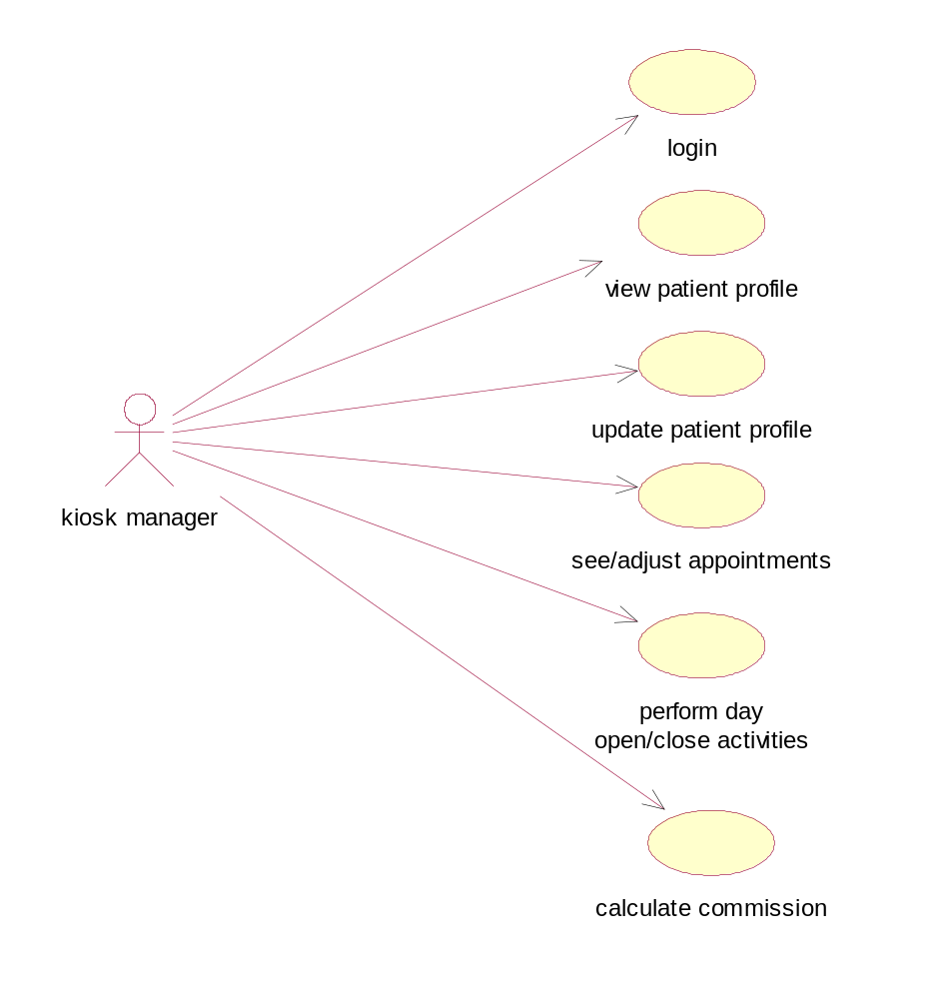

Class Diagrams:
This shows a set of classes, interfaces, collaborations and their relationships. There are the most common diagrams in modeling the object oriented systems and are used to give the static view of a system.
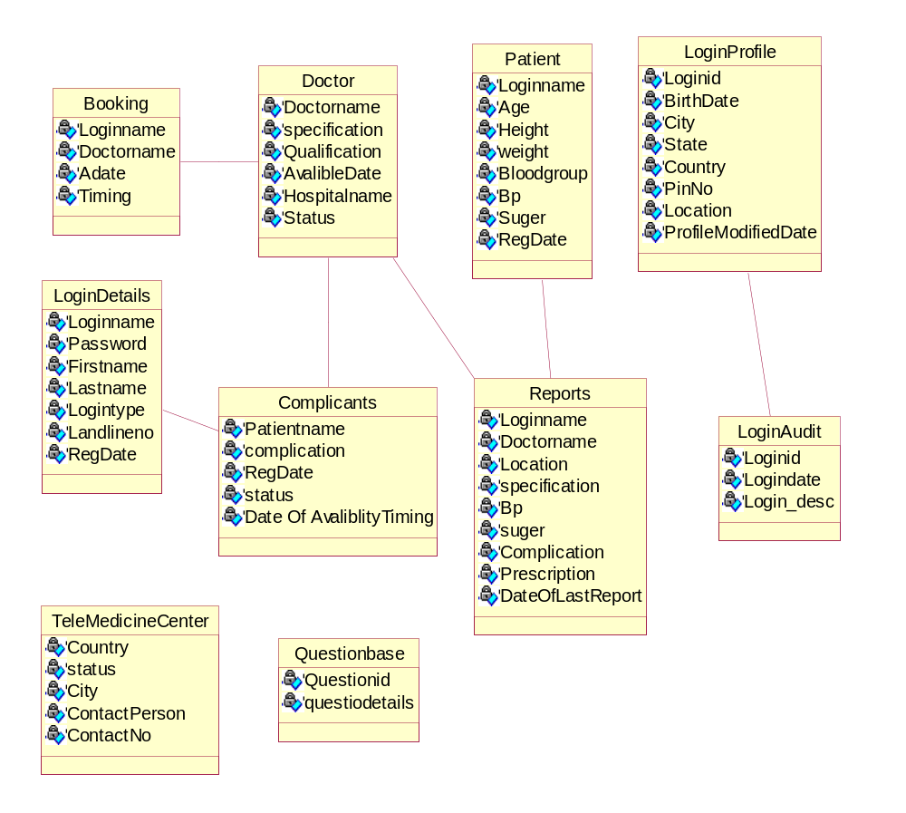

Collaboration Diagrams :
This diagram is an interaction diagram that stresses or emphasizes the structural organization of the objects that send and receive messages. It shows a set of objects, links between objects and messages send and received by those objects. There are used to illustrate the dynamic views of a system.

Login:

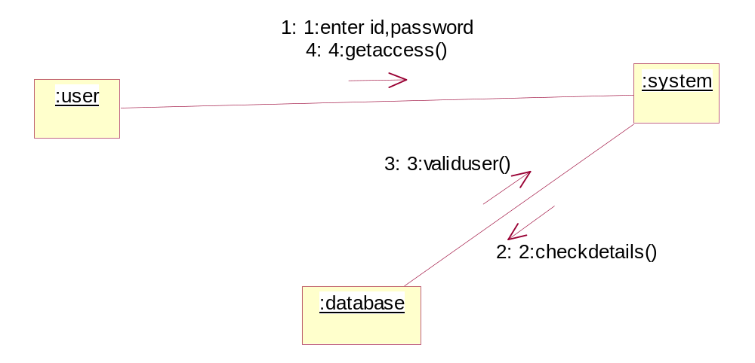

Patient Information:

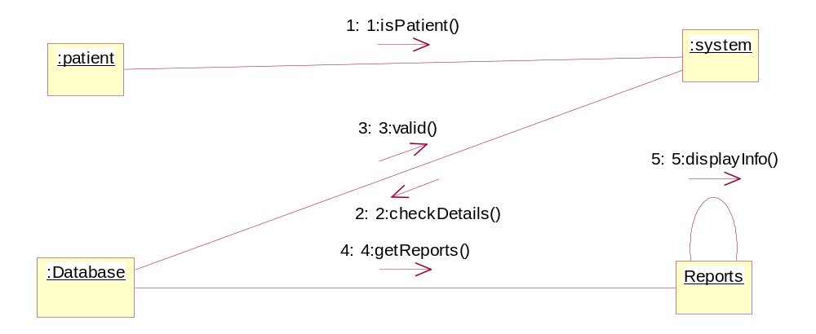

Take Appointment:

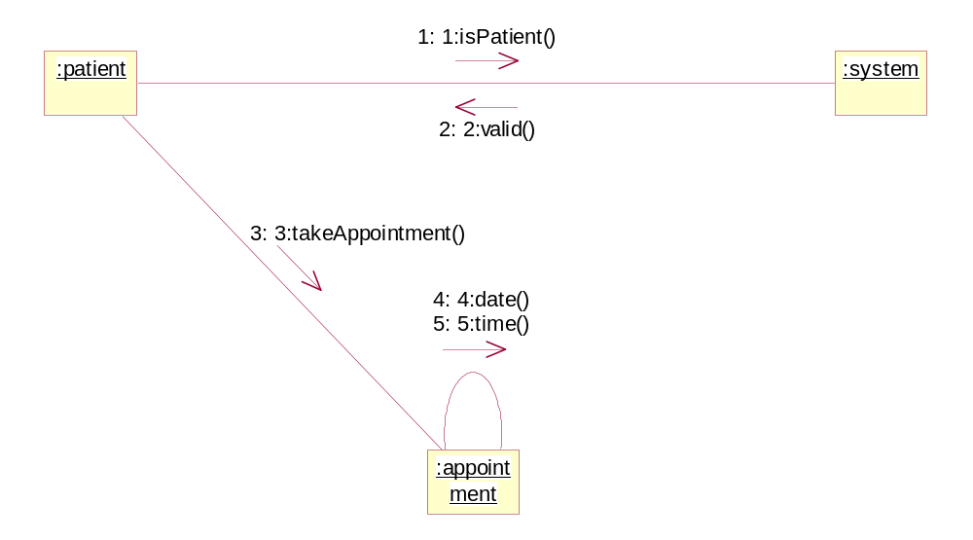

Give Appointment:

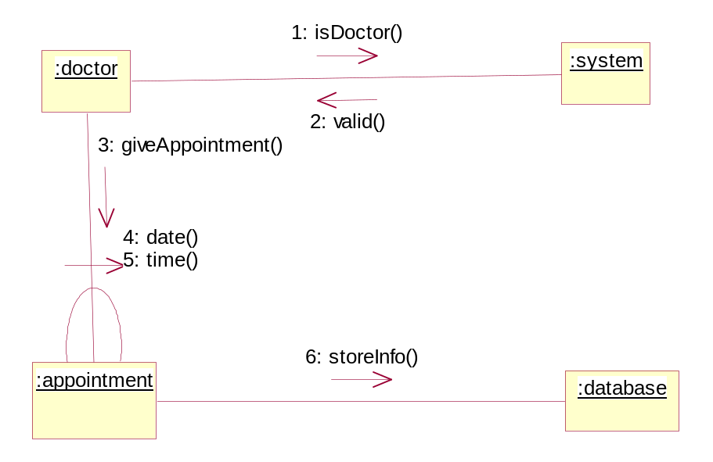

Manage Profile:

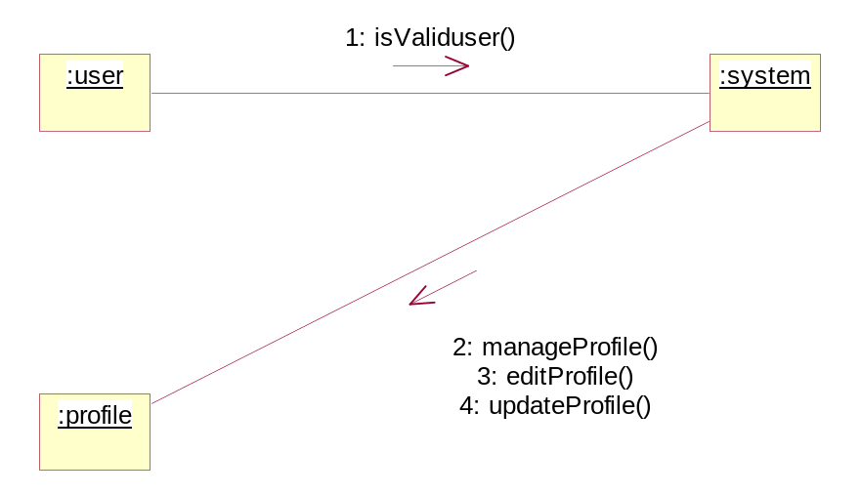

See/Adjust Appointments:

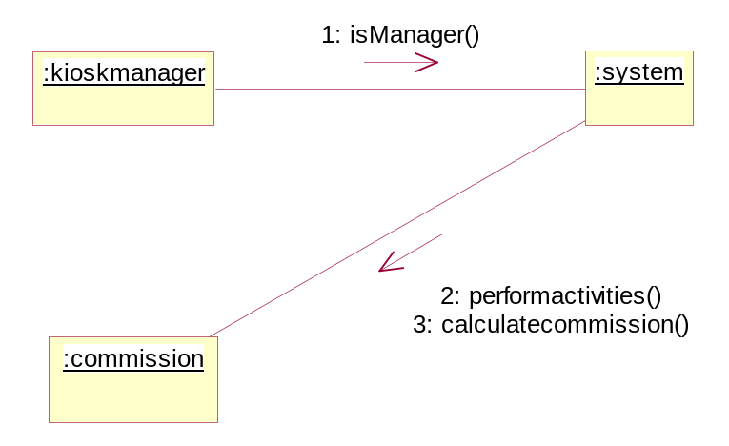

Feedback/Complaint:

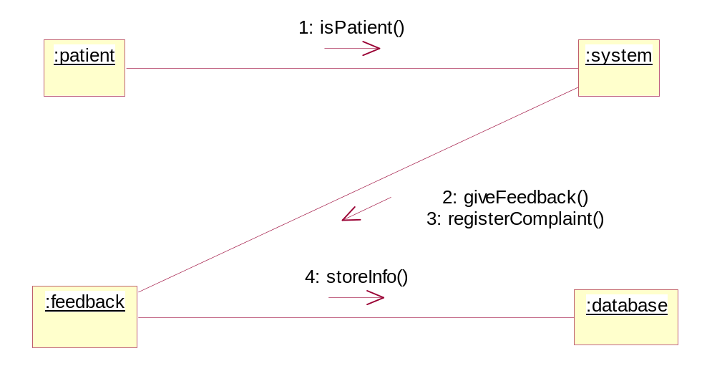

Calculate commission:

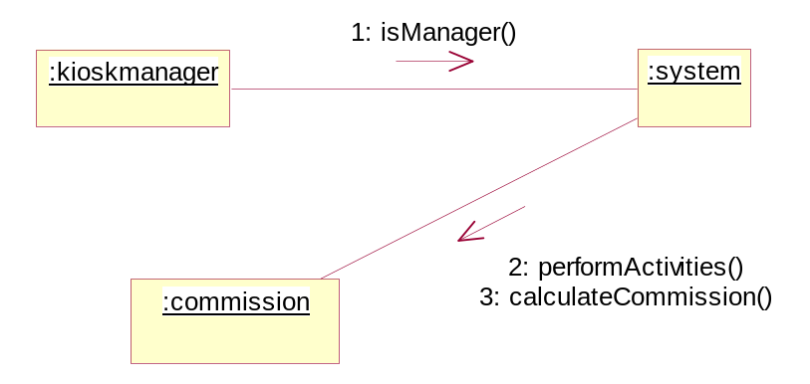

Sequence Diagrams:
A sequence diagram represents the sequence and the interactions of given case or scenario. A sequence diagram shows an interaction arranged in a time sequence.
Login:

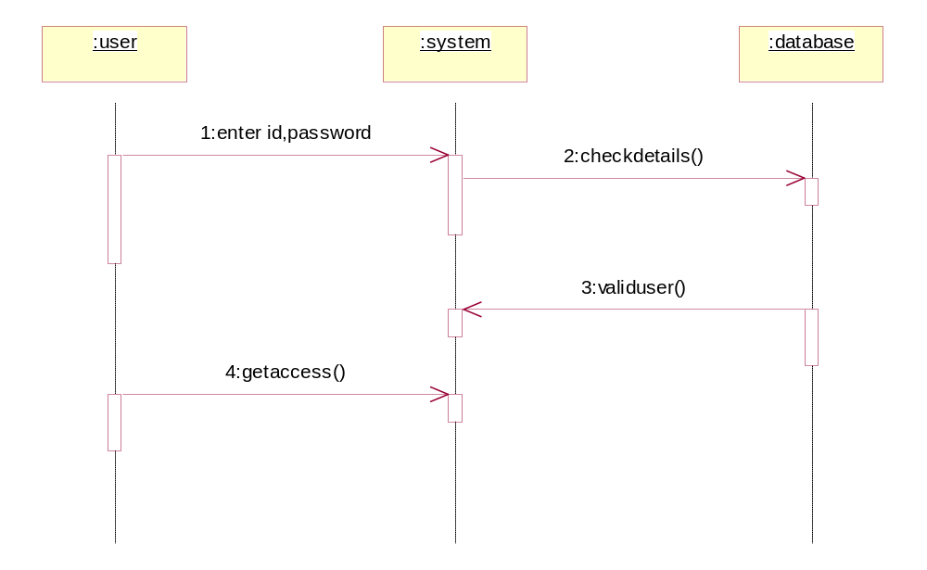

Patient Information

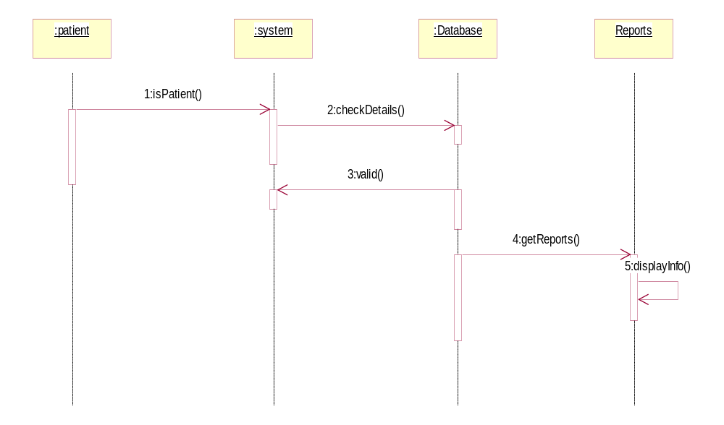

Take Appointments
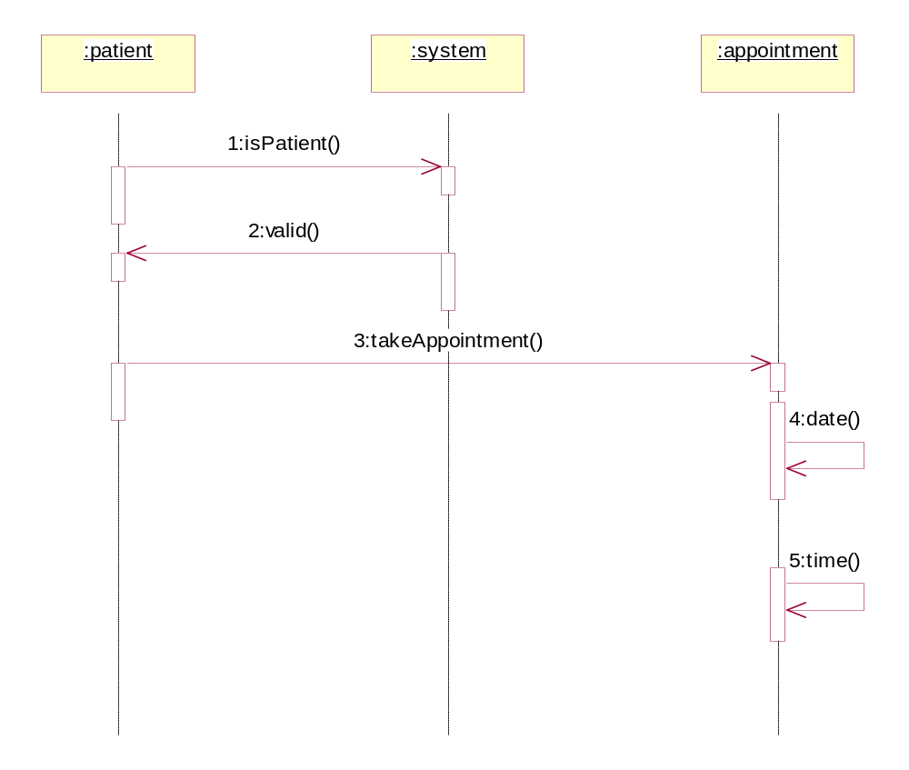
Give Appointments
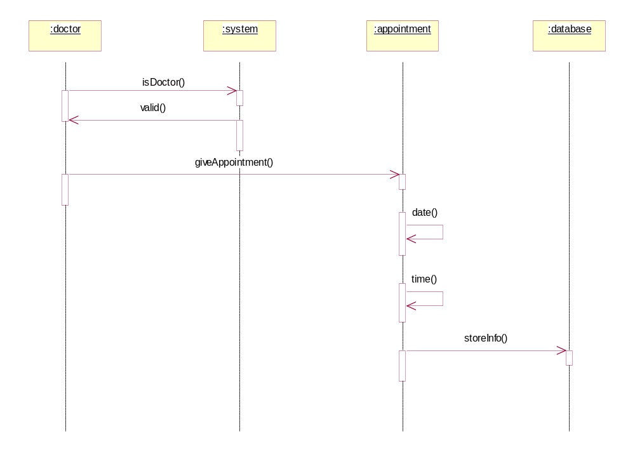

Manage profile

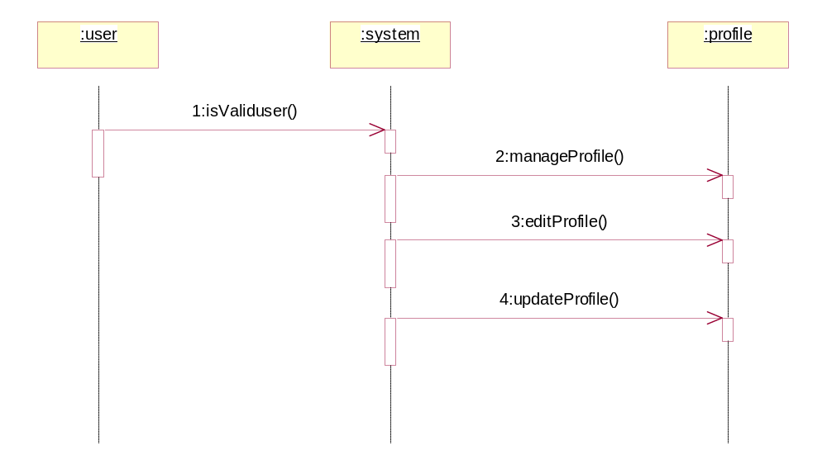

See/Adjust appointments:

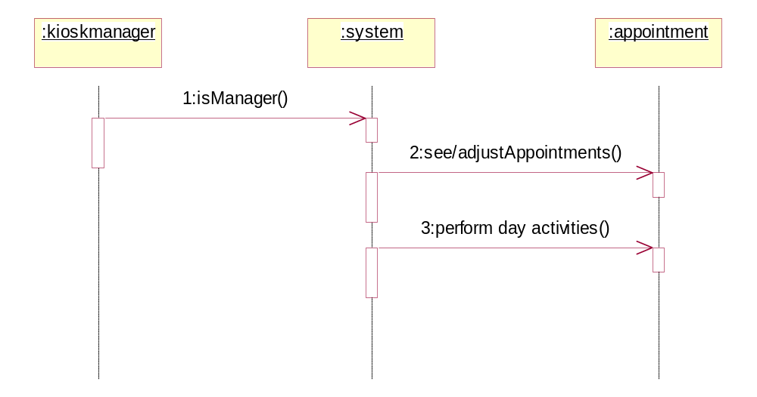

Calculate commission

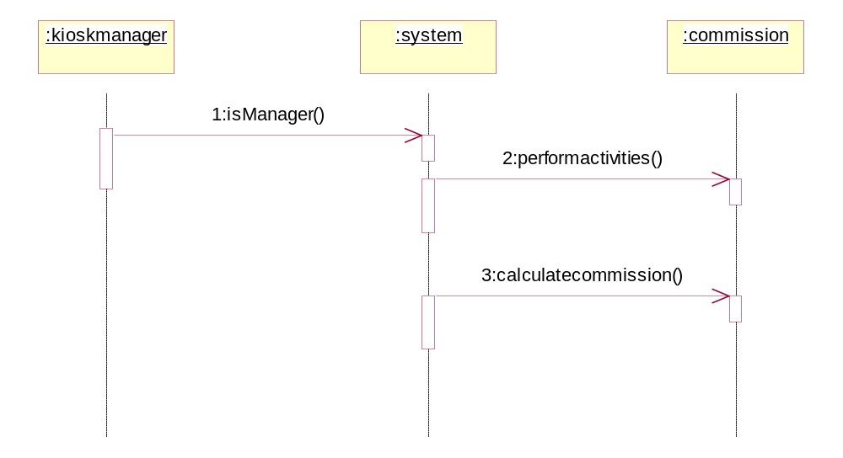

Feedback/Complaint

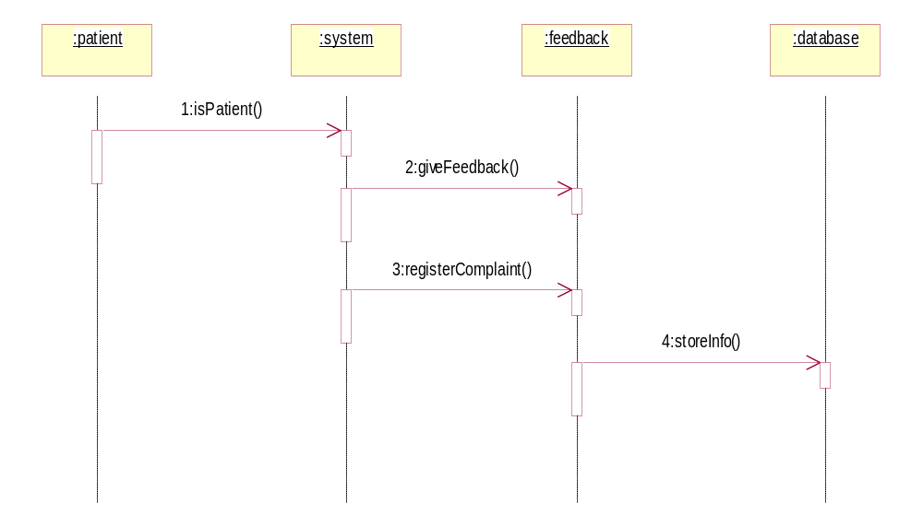

Generate Reports:

